Peter Victoratos

CSC 411

April 10, 2018

Lab 16 Neural Networks

After running the script with only the change of the classifier, I got an accuracy rating of 28.33% (seen below).

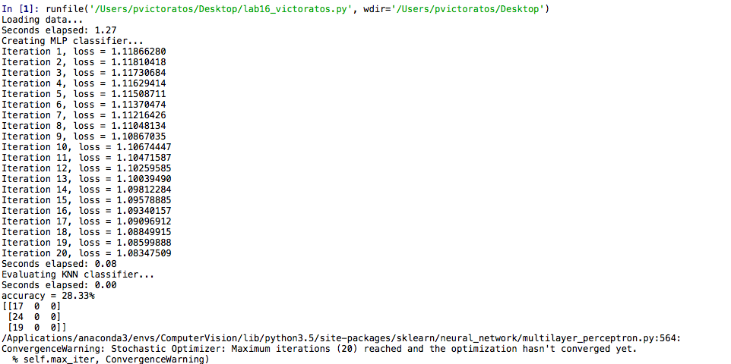

In order to improve this score, I standardized the data. By using the training data to get mean and standard deviation, I was able to redefine the test images to be more accurate. We use the training data to calculate these values rather than both training and testing because we know which data in the training set is correct and what is not. This way our model has a better idea of what we want it to look for. Below are the results after I added mean and standard deviation:

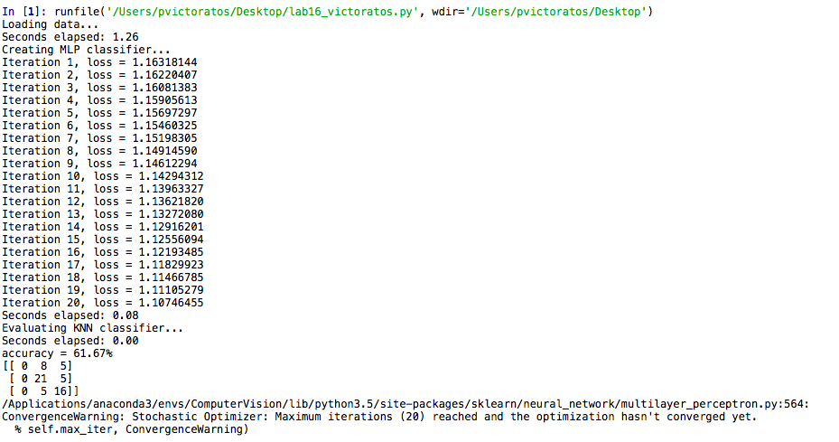

20 iterations, learning rate at 0.0001:

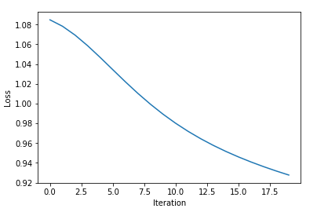

50 iterations, learning rate at 0.0001:

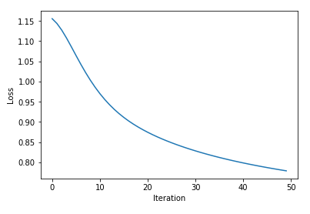

75 iterations, learning rate at 0.0001:

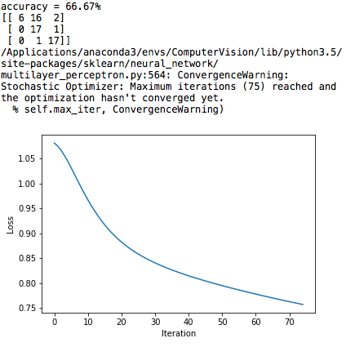

Most accurate model (50 iterations, 6 hidden layers, 0.01 train time):

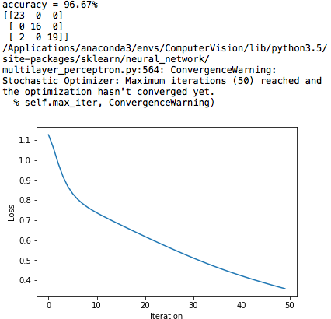

**ANIMALS DATASET!!!**

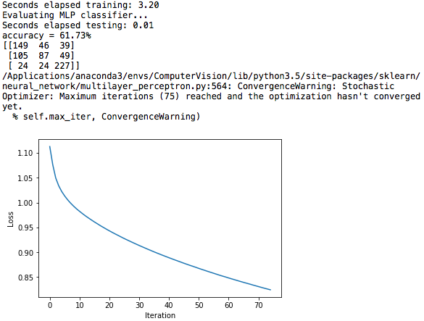Same settings, except with more iterations, over the animals data set:

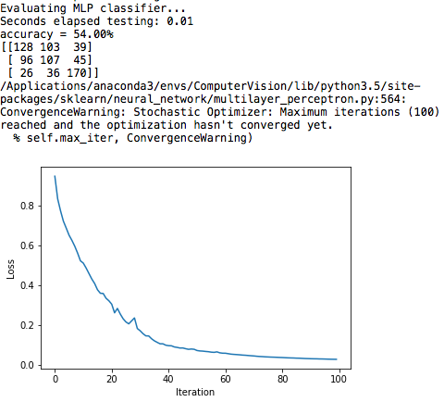Hidden Layer Sizes = 12, Max iterations = 100, Learning Rate = 0.1:

Hidden Layer Sizes = 12, Max iterations = 75, Learning Rate = 0.1:

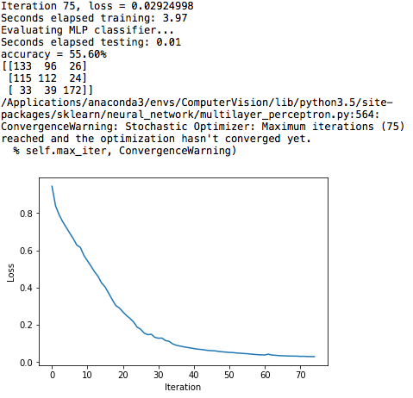

**Best Accuracy Flowers: 96.67%**

**Best Accuracy Animals: 61.73%**